Project Design Phase-II
Data Flow Diagram & User Stories

Date | 25/09/2026
Team ID | SWTID-2026-3184
Project Name | API Studdy Buddy
Maximum Marks | 4 Marks

Data Flow Diagrams:
A Data Flow Diagram (DFD) is a traditional visual representation of the information flows within a system. A neat and clear DFD can depict the right amount of the system requirement graphically. It shows how data enters and leaves the system, what changes the information, and where data is stored.
Example: 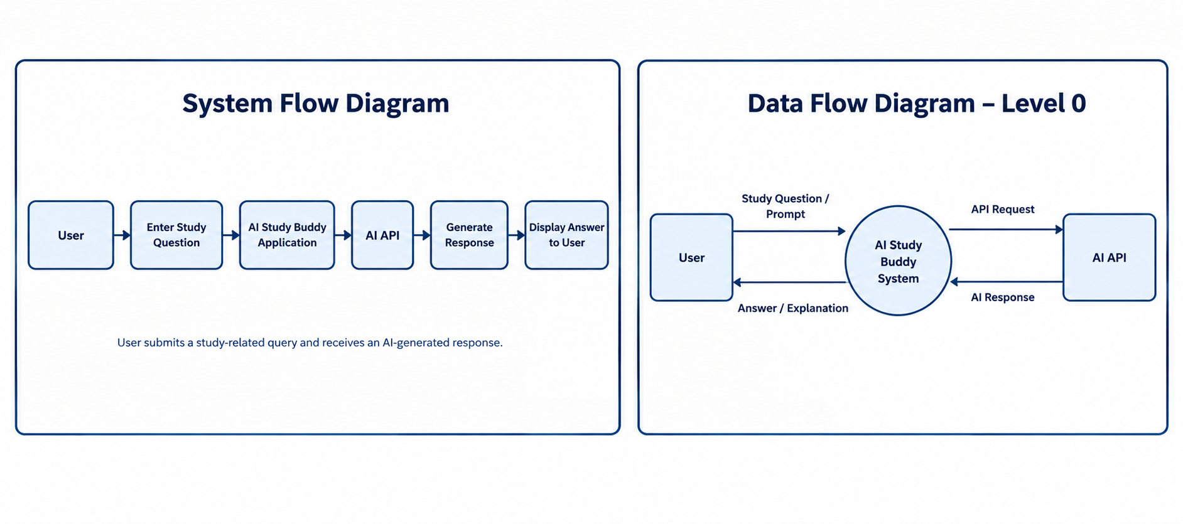

User Stories

User Type | Functional Requirement (Epic) | User Story Number | User Story / Task | Acceptance criteria | Priority | Release
Student |  | USN-1 | As a user, I can register for the application by entering my email, password, and confirming my password. | I can access my account / dashboard | High | Sprint-1
  AI Study Assistance
Student |  | USN-2 | As a user, I will receive confirmation email once I have registered for the application | I can receive confirmation email & click confirm | High | Sprint-1
  AI Study Assistance
Student |  | USN-3 | As a user, I can register for the application through Facebook | I can register & access the dashboard with Facebook Login | Low | Sprint-2
  AI Study Assistance
Student | AI API Integration | USN-4 | As a user, I can register for the application through Gmail | The API request is successfully processed and a response is returned. | Medium | Sprint-1
Student | Chat Interface | USN-5 | As a user, I can log into the application by entering email & password | Questions and responses are displayed clearly. | High | Sprint-1
Student | Chat Interface | USN-6 |  | I can submit multiple questions without restarting the application. | High | Sprint-2
  As a user, I can enter a new question after receiving a response.
Student | Error handling | USN-7 | As a user, I can receive an error message when the AI API is unavailable. | A clear error message is displayed when the API request fails. | Medium | Sprint-2
Student | Performance Testing | USN-8 | As a developer, I can test the AI Study Buddy under different user loads. | The application responds successfully under the selected test load. | Medium | Sprint-3
Student | Testing | USN-9 |  | The AI provides responses for different valid queries. | High | Sprint-3
  As a developer, I can test different study-related questions.
Student | Documentation | USN-10 |  | Project setup, features, and system workflow are documented. | High | Sprint-3
  As a team, we can document the setup and working of the AI Study Buddy.
Student | User interface | USN-11 | As a user, I can use the application through a simple and user-friendly interface. | All main features are accessible and easy to use. | High | Sprint-4
Student | Deployement | USN-12 | As a developer, I can configure the API and run the applicatio | The application runs successfully with the required API configuration. | Medium | Sprint-4

